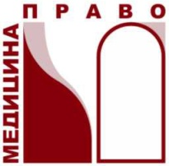
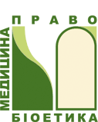
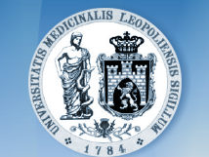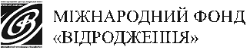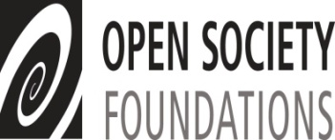

Program of the workshop
for the faculty staff of the discipline “Medical law of Ukraine”
(2 – 4 October, 2014, city of Lviv)

2 October, 2014
08.00 – 09.30 |  | Breakfast, registration of participants
09.30 – 09.45 |  | Welcome speech. Introductions
09.45 – 10.00 |  | Presentation  of the Resource Guide “Health Care and Human Rights” and Practitioner Guide “Human Rights in Patient Care” (new editions) and other sources.  Presentation of the journal “Medical Law”  Moderator: Iryna Senyuta, Dmytro Klapatyi
10.00 – 11.20 |  | Session on the topic “Novelties in the Laws of Ukraine in the Sphere of Health Care”  Moderator: Iryna Senyuta
11.20 – 12.00 |  | Session (presentation of a film; discussion of interactive methods of lecturing)  Moderator: Iryna Senyuta, Dmytro Klapatyi
12.00 –12.15 |  | Coffee-break
12.15 – 13.30 |  | Master-class  Moderator: Andre den Exter (city of Rotterdam, The Netherlands)
13.30 – 14.30 |  | Lunch with and expert
14.30 – 15.30 |  | Educational training «Health Care and Human Rights: international and regional instruments»  Moderator: Iryna Senyuta, Dmytro Klapatyi
15.30 – 18.00 |  | Preparation of author’s plan of the lecture and practical class on the course “Medical law” and presentation of the results  Moderator: Iryna Senyuta
18.30 – 20.00 |  | Friendly dinner
3 October, 2014
08.00 – 09.00 |  | Breakfast
09.00 – 10.30 |  | Session (presentation)  «Formation of a positive motivation of students to studying»  Moderator: Tetyana Ravchyna
10.30 – 11.00 |  | Session «Medical and legal clinics: peculiarities of functioning»  Moderator: Iryna Senyuta
11.00 – 11.15 |  | Coffee-break
11.15 – 12.00 |  | Session «Medical neutrality: access to health care concept»  Moderator: Iryna Senyuta, Dmytro Klapatyi
12.00 – 13.00 |  | Master-class  Moderator: Vasyl Ruden
13.00 – 14.00 |  | Lunch with an expert
14.00 – 15.30 | Round table «Peculiarities of lecturing academic discipline “Medical Law of Ukraine”: model programs, staff and resources provision”  Moderator: Iryna Senyuta, Khrystyna Tereshko
15.30 – 16.30 | Master-class  Moderator: Oksana Kashyntseva
16.30 – 17.30 | Session «Experience of lecturing academic discipline “Medical Law” in Ukraine and abroad”  Moderator: Iryna Senyuta
17.30 – 18.00 | Summing up of the workshop. Certificate ceremony
18.00 – 19.00 | Dinner
4 October, 2014 р
09.00 – 15.00 | Sight-seeing
15.00 – | Departure of participants

